William Jagels
Fall 2014 due: Nov. 13

PROBLEM SET NUMBER FIVE

1. Melissa buys an iPhone for $120 and gets consumer surplus of $80.
a. What is her willingness to pay?
$200 = 120 + 80
b. If she had bought the iPhone on sale for $90, what would her consumer surplus have been?
$110 = 200 - 90
c. If the price of an iPhone were $250, what would her consumer surplus have been?
-$50 = 200 - 250

2. Suppose that the market for soybeans in U.S is given by the following equations:
demand: Qd = 500-10P
supply: Qs = 5P-100
where P is the price per bushel of soybeans and Q is the number of bushels of soybeans.
a. Suppose the world price of per bushel of soybeans is $25, what’s the
Producer surplus? 62.5
Consumer surplus? 3125
Total surplus? 3187.5
b. Now a tariff of $5 is imposed on each bushel of soybeans importing from other countries, what’s the
Producer surplus? 250
Consumer surplus? 2000
Government revenue? $750
Total surplus? 2250
c. Is the tariff good for U.S? Explain. It’s bad for consumers, as they lose a significant amount of consumer surplus, but it’s good for the producers as they gain significant surplus and sell more.

3. When China’s clothing industry expands, the increase in world supply lowers the world price of clothing.
a. Draw an appropriate diagram to analyze how this change in price affects consumer surplus, producer surplus, and total surplus in a nation that imports clothing, such as the United States.

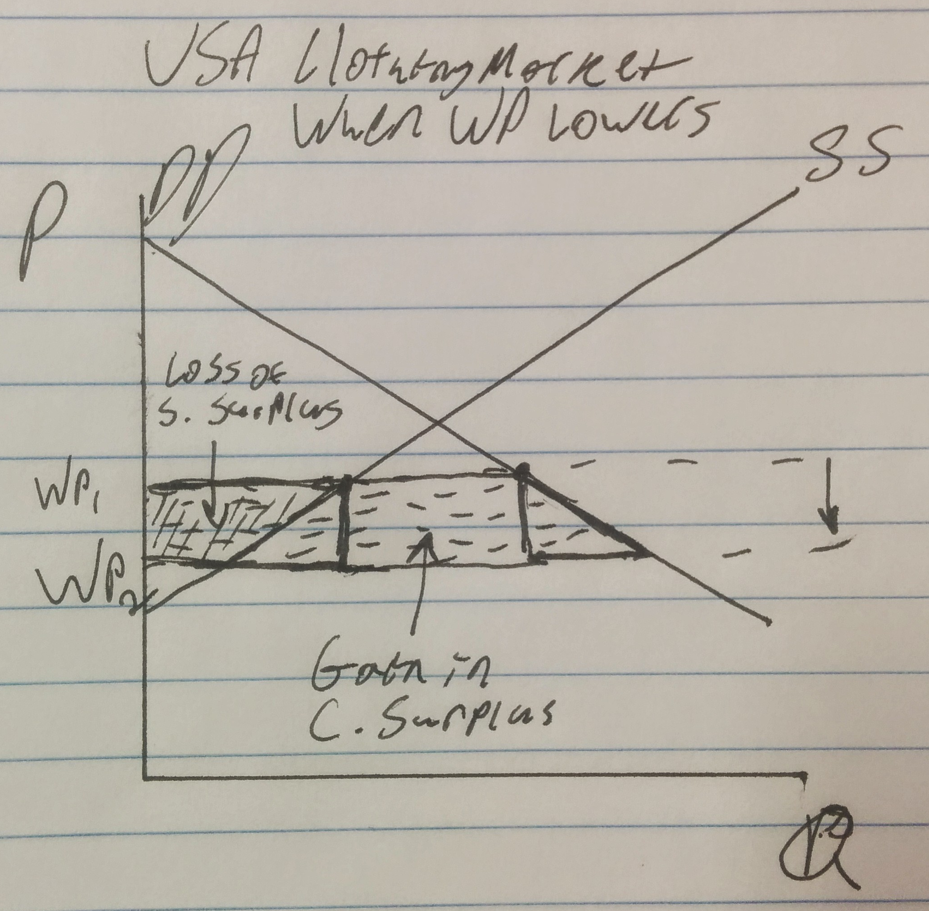
b. Now draw an appropriate diagram to show how this change in price affects consumer surplus, producer surplus, and total surplus in a nation that exports clothing, such as the Dominican Republic.
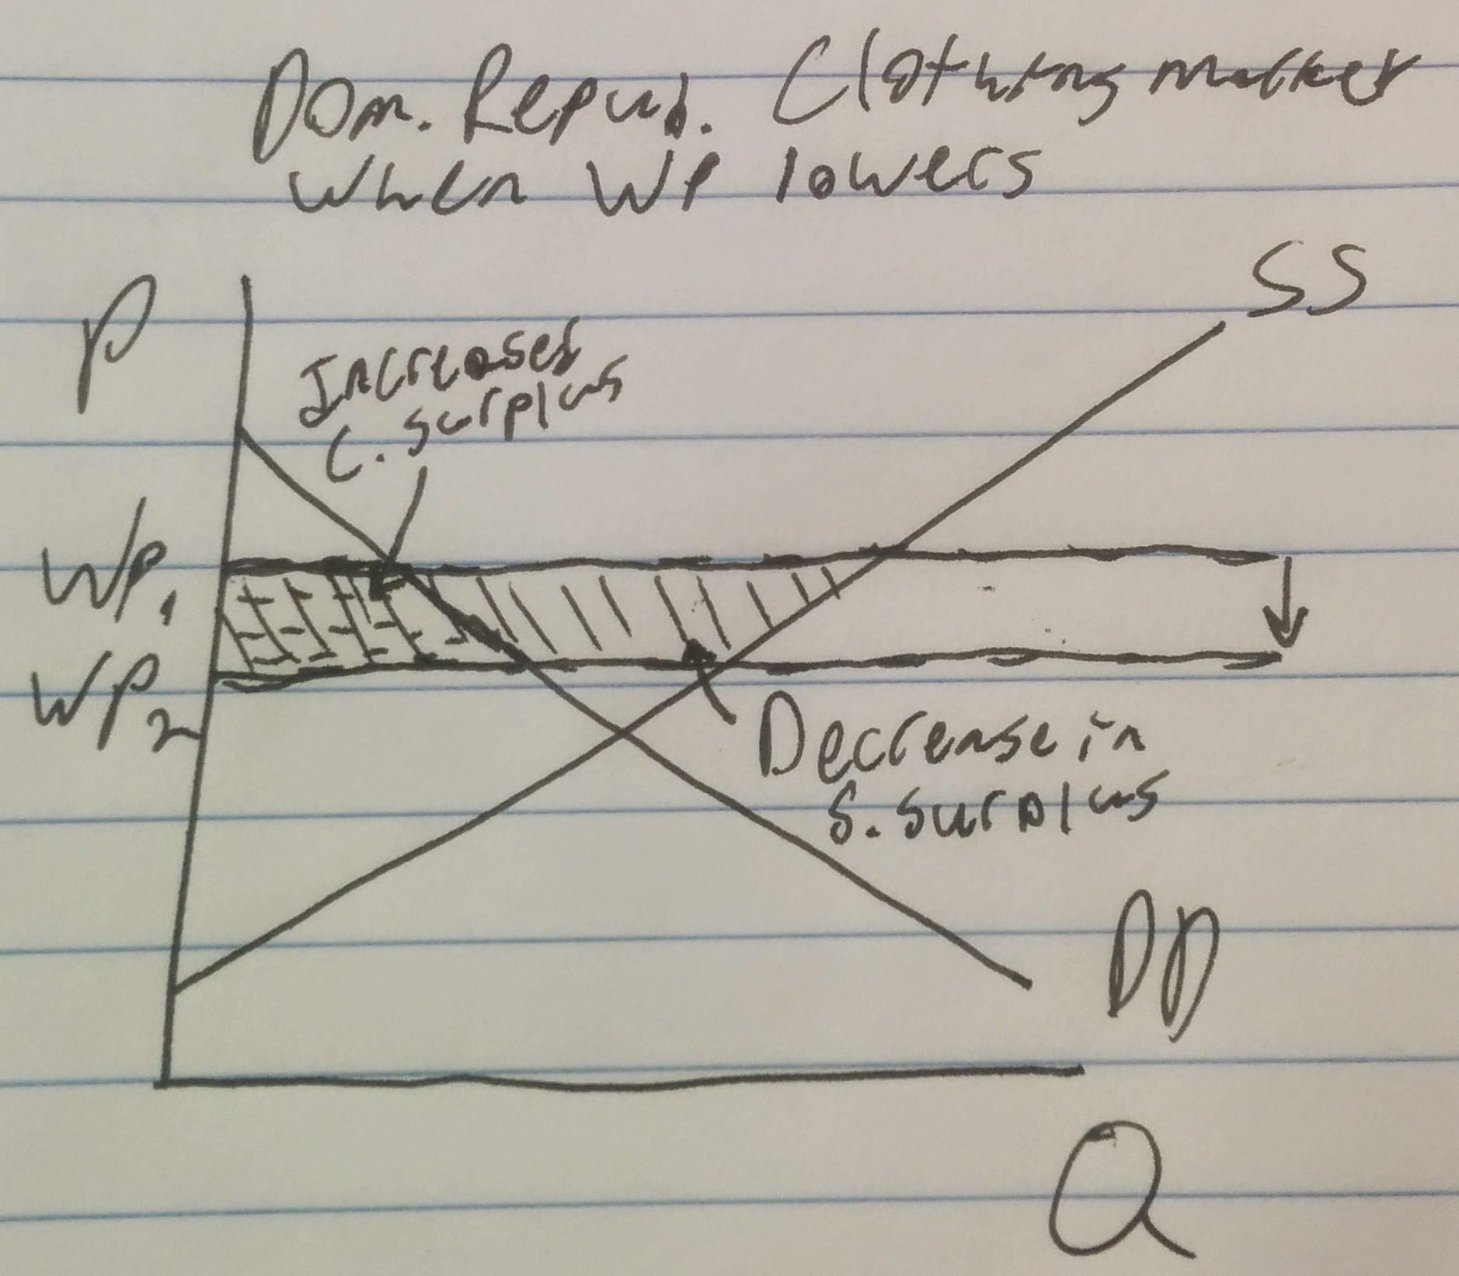
c. Compare your answer to parts (a) and (b). Which country should be concerned about the expansion of the Chinese textile industry? Which country should be applauding it? Explain.
The Dominican Republic should start panicking about this because now that their supply surplus is greatly reduced, they can’t export as much as before. The USA benefits greatly, as the consumer now has a larger surplus, and therefore, a greater well-being. The total surplus goes down in Dom. Republic, and in the USA it goes up.

Work for Question 2
